# Map File to FTI File Parser Help

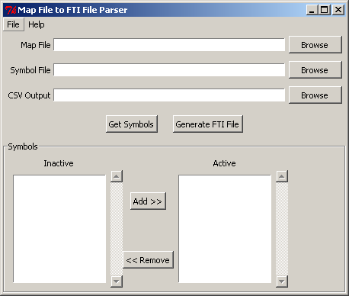

## Introduction

The Map File to FTI Parser has been developed to convert .map files generated by a C Compiler to a suitable comma seperated values format that is compatible with the FTI Software.

The application has been written using Python version 2.7.2 and Tk version 8.5

## Usage Instructions

In order to generate an FTI file you need to have a .map file and a symbols file. Select the correct map file by pressing the upper most “Browse” button.

* Select the correct symbol file by selecting the middle “Browse” button.
* To create a new map file use the lower “Browse” button to select the new file name and location.
* Press “Generate FTI File” to generate the file.

## Symbols

The program allows the user to select a sub-set of the symbols from a symbol file to generate a FTI file. The screen shot below shows where the user has selected only 2 out of the 3 possible symbols. The file generated from this will only contain the symbols within the active list.

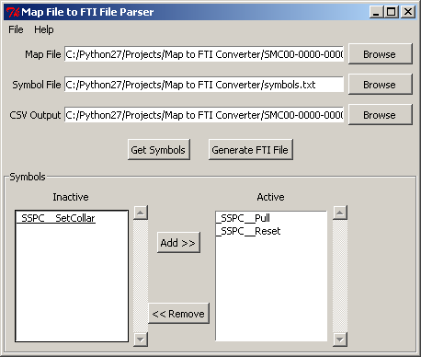

To load symbols, select a valid symbol file using the middle “browse” button and then press “Get Symbols”. The loaded symbols will be added to the Inactive list. To move an item across to the Active list, select the item and then press “Add>>”. To remove an item from the Active list, select it and press the “<<Remove” button, the item will move back to the Inactive list.

## Project File

Users can chose to save the current settings shown on screen within a Project File. The following settings will be saved.

* Map File Location
* Symbol File Location
* CSV Output File Location
* Active and Inactive Symbols
* Split Large Symbols option (Described in Split Large Symbols section)

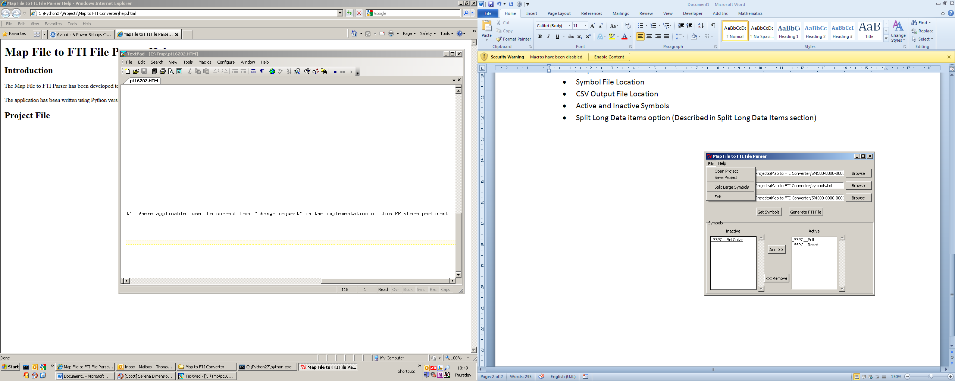

Saved project files can be re-opened allowing the user to reload all the previous settings.

## Split Large Symbols

A .map file may contain data items which are of a large size (>4 bytes), in this case the user has an option to split the file up in to Double Words (4 byte).

For example

Data item named “Large List” is describes as being 16 bytes in length. When the Split Large Symbols option is selected the FTI Output will show the following;

Large_List_0,Data Address,Size,Mask  
Large_List_1,Data Address,Size,Mask  
Large_List_2,Data Address,Size,Mask  
Large_List_3,Data Address,Size,Mask